|  |  |
| --- | --- |
|  | 🞂Target guarding problem in probabilistic setting  Problem in deterministic setting |
|  |  |
|  | **Naveen Kothuri** 🞂INDIAN INSTITUTE OF TECHNOLOGY, MADRAS 🞂 11/18/2017 |
|  |  |
|  |  |
|  |  |
|  |  |
|  |  |
|  |  |
|  |  |
|  |  |
|  |  |
|  |  |
|  |  |
|  |  |
|  |  |
|  |  |
|  |  |
|  |  |
|  |  |
|  |  |
|  |  |
|  |  |
|  |  |
|  |  |
|  |  |
|  |  |
|  |  |
|  |  |
|  |  |
|  |  |
|  |  |
|  |  |

***Problem in deterministic setting:***

*Consider a target guarding problem where in evader (E) tries to cause as much destruction as possible to target (T) and pursuer (P) protects the target by trying to stop the target (T). For simplicity, assume evader and pursuer move with constant velocity. The reachable space of E before P intercepts him is dominance region of E. The reachable space of P before E reaches the target is dominance region of P. Evader wins if T is in his dominance region and P wins if T is in his dominance region. The boundary separating these two dominance regions is [1]*

*C: *

*where, *

**

* is E’s position in Cartesian coordinate system.*

 *is T’s position in Cartesian coordinate system.*

 *is P’s position in Cartesian coordinate system.*

* , whereand are the velocities of the E and P respectively.*

*So C is the set of all points where interception of E by P can happen depending on the direction in which E moves.*

*If T is in P’s dominance region, no matter in which direction E chooses to move, he will be intercepted anyways. So the best thing for E to do is to get himself intercepted at the closest point (I) to T on C. Hence this is considered as optimal play for E. For P to intercept E at I, he has to head towards I. So this is the optimal play for E.*

*So from*, *the closest point on C can be given as*

*, *

*Where *

***In probabilistic setting:***  *For P to head towards the optimal interception point, he has to have position and velocity of E. But the measurement always comes with variance and no exact measurement is possible in real time. So if E’s position and velocity are not known precisely then this work tries to answer the question - what should be the strategy of P for him to go as close as possible to interception point before E reaches T, if not to the interception point.*

*This problem can be formulated such that a Kalman filter can be designed to find the interception point.*

***Kalman Observer for target guarding problem:***

*Assumptions:*

1. Evader (E) moves with constant velocity (no process noise) and he knows the pursuer’s initial position and velocity.
2. He plays optimally and moves toward the interception point (I)**.**
3. The sensor has normally distributed measurement noise.
4. Pursuer (P) also moves with constant velocity.

*Model:*

*Let the initial position of E be  and initial velocity be. Evader’s position and velocity are considered as states.*

  

*Where and  are velocities in  and  directions.  is step size*.

*Output:*

,

*where*,,  *are noises with normal distribution. is the covariance matrix of the noises.*

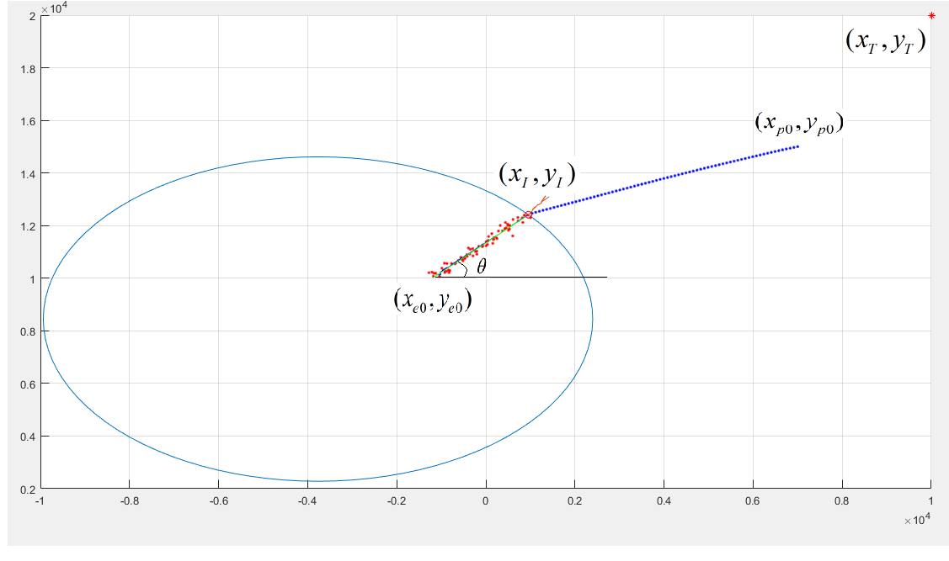

*State space model:*

 , 

*Where*

*(A, C) is observable.*

*Kalman filter:*

--- (1) 

*Where  is the estimate at time  based on outputs of the system till time.*

* is the next state with  as present state*.

*Input,* = 

